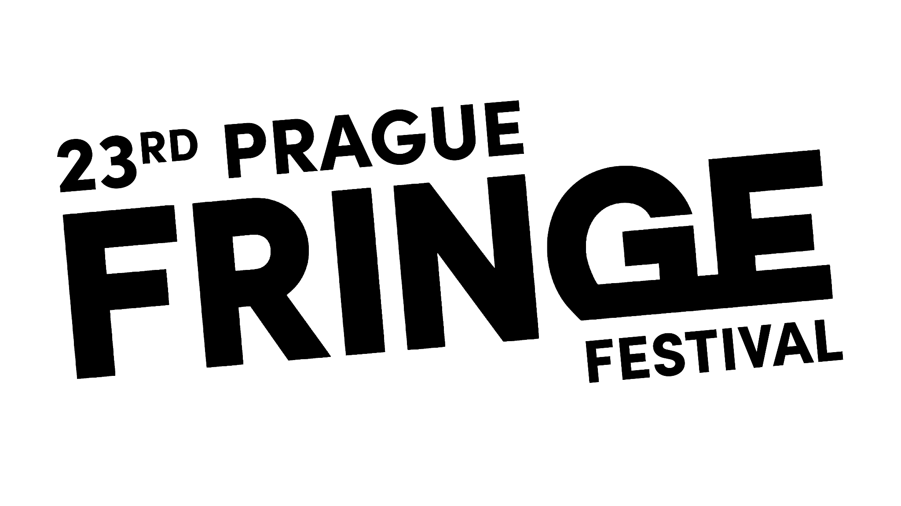
From Taiwan to India to Žižkov: Prague Fringe Festival 2024 Offers a Cultural Kaleidoscope in Malá Strana!
Tickets are on sale now for the Czech Republic’s very own slice of Edinburgh on the Vltava.
From Monday 27th May – Friday 1st June audiences can enjoy over 140 performances of 36 productions from 15 different countries around the world! The traditional (and not so traditional) theatres and performance spaces of Prague’s Malá Strana district will once again be filled with international, award-winning, ground-breaking theatre, comedy, children’s shows, story-telling and more.
The festival team have curated an incredibly diverse range of options for audiences to enjoy - from The Untold Fable of Fritz and King John for family fun, to late night stand-up with Bombay Comedy!
Returning favourites such as the award-winning Pip Utton, Henry Naylor and Emily Carding are back, as well as brand new work from fresh, young performers and producers and shows from Japan, Taiwan, Finland, Australia and even Ukraine.
Prague Fringe Founder and Director Steve Gove says “It’s going to be a belter!” “We’ve curated our most international Fringe in years, packed full of incredible quality productions from around the world, brand-new works and Czech premieres and two whole venues dedicated to comedy!
The festival is back in its favourite Malá Strana venues including Divadlo Inspirace, A Studio Rubín, Museum of Alchemists and Café Club Míšeňská. Plus this year sees two venues dedicated to comedy - the return of last year’s successful Charles Bridge Comedy Club and a brand new venue in the basement of OG Glenn’s Bar which is hosting a full programme of stand-up and comedy shows. Fan favourite Malostranská beseda is back for the larger-scale productions including the talented young actors from the Australian Shakespeare Company, the 5* musical Happily Ever Poofter, Youtube hit sensation UnErase Poetry - Stories from India from Mumbai, a sexy scientific exploration of the Chemistry Of Love by Dr. Michael Londesborough, MBE, and an exclusive Fringe-version of the Czech legendary (fictional) playwright Jára Cimrman’s the Stand-In performed by the Cimrman English Theatre.
On Thursday 30th May there are international performances taking place with 2 shows performed in the original Italian (Alice No, and Be My Guest), and UnErase Poetry - Stories from India performed in Hindi.
To keep things as affordable as possible, the popular Prague Fringe Pass is available again for 1100Kč which saves the user 20 Kč on each ticket (as well as only paying a single ticket booking fee for the transaction).
Advance tickets are 250Kč (or 220Kč for students/seniors) and tickets purchased at the venue (selected venues only) are 300Kč – subject to availability. The Fringe is a cash-free Festival. All major credit cards are accepted.
/ / /
Contact for Press: press@fringe.cz
Browse the full programme: www.praguefringe.com
All show photos: https://tinyurl.com/4nr3yk7j
2024 Logo: https://www.praguefringe.com/new/fileadmin/user_upload/logo24.png

